Music Classification with Signal Processing and Convolutional Neural Networks
University of Washington, Master of Science in Technology Innovation
TECHIN 513 DSP

Coleman Bryant & Daniel Zelinger

Abstract
This project built a unified music analysis system with two separate convolutional neural network pipelines: one for genre classification on GTZAN and one for dominant-instrument classification on a four-class Kaggle musical instrument dataset. Both pipelines used log-mel spectrograms as image-like inputs and compared simple baselines against progressively refined CNN variants. The genre experiments showed meaningful learning but also strong sensitivity to training details and reproducibility, with a 0.65 baseline, an earlier best CNN result of 0.77, and later reproducible reruns between 0.61 and 0.64. The instrument experiments were more stable, improving from a 0.48 baseline to a best validation accuracy of 0.7148. The project therefore contributed not only working classifiers and a live demo workflow, but also a clear analysis of ablations, confusion patterns, and experiment tracking in Colab.

1 Introduction
This project explores whether a compact signal-processing and machine-learning workflow can identify both the genre and the dominant instrument of a short music clip. The system is intentionally split into two models rather than one multitask network. The first model predicts one of ten GTZAN genres, and the second predicts one of four instrument classes: drum, guitar, piano, and violin. This design kept the scope manageable, made ablation testing easier, and supported a demo in which the same audio clip could be passed through both models to produce complementary outputs.
The overall project goal was not only to maximize accuracy, but also to justify the complete pipeline from feature extraction to model evaluation. That meant establishing meaningful baselines, testing multiple CNN revisions, examining confusion matrices, and documenting where the models were strong, weak, and unstable. This was especially important for genre classification, where the recreated runs did not consistently match the strongest earlier result.

2 Datasets and Features
The genre model used the GTZAN dataset, filtered to remove a corrupted file and then split into train, validation, and test partitions. Each clip was represented with a log-mel spectrogram derived from mono audio at 22,050 Hz. The main feature settings in the best reproducible genre pipeline were 3.0-second crops, 64 mel bands, an FFT size of 2048, a hop length of 512, and a frequency range from 20 Hz to 11,025 Hz. Per-example standardization was applied so each spectrogram crop had zero mean and unit variance before entering the model.
The instrument model used the Kaggle Musical Instrument Sound Dataset, narrowed to four classes that were practical for training and demo use: drum, guitar, piano, and violin. As with the genre pipeline, the instrument pipeline transformed fixed-length audio clips into 2D log-mel spectrogram representations so a CNN could learn local time-frequency patterns such as transients, sustained harmonics, and rhythmic structure. Using the same general feature family across both tasks helped make the overall system coherent and easier to explain.

3 Methods

3.1 Baselines
For genre classification, the baseline used mel-spectrogram summary statistics rather than a CNN. Mean and standard deviation were computed across mel bands, then passed through a standard scaler and logistic regression classifier. This produced a competitive 0.65 test accuracy. For the instrument task, the baseline also used a simpler non-CNN approach and achieved 0.4848 accuracy, but it failed badly on drum and violin, which justified moving to a convolutional model.

3.2 CNN design
Both tasks used small convolutional neural networks instead of very large architectures. This choice was deliberate. The datasets were modest in size, the input representation was already image-like, and a compact model was faster to train and easier to debug in Colab. The genre CNN family used stacks of 2D convolutions, batch normalization, ReLU activations, max pooling, dropout, and a dense classification head. The instrument CNN family followed the same general pattern but explored architecture changes that affected the balance between classes.
The genre pipeline also used multi-crop evaluation. Instead of predicting from one arbitrary window, the model processed multiple deterministic crops from the same track and averaged the predicted probabilities. This reduced the effect of any single short window and made the evaluation more stable. Several runs also tested SpecAugment-style masking, which randomly removed time or frequency regions during training to encourage more robust representations.

3.3 Reconnect-safe demo workflow
A practical part of the project was making the demo robust to Colab disconnects. Early in the work, a strong genre run was not fully reproducible later because the notebook session had not been backed up to Google Drive before disconnecting. That mistake became part of the report rather than something to hide, because it directly affected which artifacts remained available for later comparison. After rebuilding the workflow, both notebooks were updated to load saved models, label arrays, and persistent demo audio files from Drive so the demo could be rerun after reconnecting without retraining.

4 Results

4.1 Genre classification
The genre results were mixed but informative. The baseline logistic-regression model achieved 0.65 test accuracy. An earlier CNN v2 reached 0.73, a later v3 run dropped to 0.62, and an earlier saved v4 run reached 0.77. However, when the v4 pipeline was rebuilt under controlled conditions, the recreated runs reached only 0.63 with SpecAugment, 0.61 when training crops per track were increased to six, and 0.64 when SpecAugment was turned off. The strongest practical conclusion is therefore not that the genre CNN consistently dominated the baseline, but that it functioned correctly while remaining sensitive to training configuration and experiment reproducibility.
Table 1: Genre classification summary.
Run | Setting | Acc.
Base | LogReg | 0.65
v2 | 3 s + multi | 0.73
v3 | 5 s + multi | 0.62
v4* | SpecAug + multi | 0.77
v4-r | 3 s + SpecAug | 0.63
v4-a | 6 train crops | 0.61
v4-a | SpecAug off | 0.64
The confusion matrices showed that some genre classes were consistently easier than others. Classical, metal, and hiphop were often among the strongest classes, while rock was the most persistent weakness. Country, disco, and jazz were more unstable across runs. Figure 1 shows the row-normalized confusion matrix for the best reproducible recent run, the no-SpecAugment ablation at 0.64. The strong diagonal for classical and metal indicates that the model learned meaningful genre-specific time-frequency patterns, but the off-diagonal entries for rock, disco, and blues show that neighboring genres still overlapped in timbre, rhythm, or instrumentation.
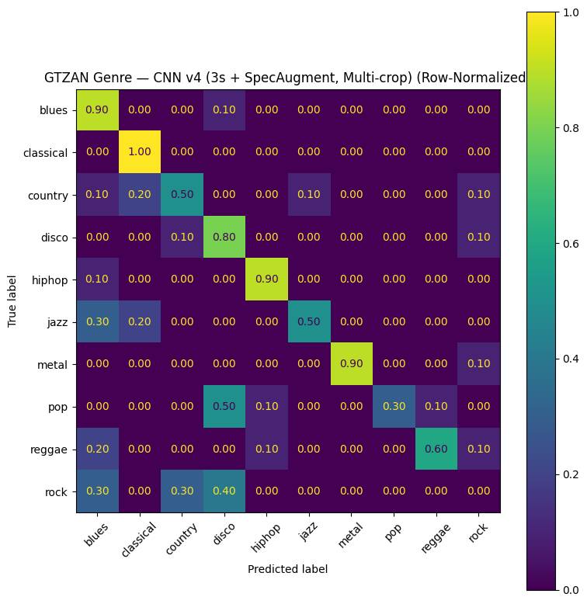
Figure 1: Row-normalized confusion matrix for the genre CNN v4 no-SpecAugment reproducible run (0.64 accuracy).

4.2 Instrument classification
The instrument classifier showed a clearer improvement trend. The baseline accuracy was 0.4848. CNN v1 improved to 0.6806, v2 reached 0.6825, v3 reached 0.7110, and v4 reached 0.7148. Unlike the genre results, the instrument experiments were more consistent in showing that the CNN outperformed the baseline. However, the main class-level tradeoff remained stable across versions: guitar and piano were recognized well, while drum and violin often interfered with each other.
Table 2: Instrument classification summary.
Run | Setting | Acc.
Base | non-CNN | 0.4848
v1 | initial CNN | 0.6806
v2 | BN + GAP | 0.6825
v3 | balanced rev. | 0.7110
v4 | best val | 0.7148
Figure 2 shows the validation confusion matrix for instrument CNN v4. Guitar and piano are nearly solved in this run, while drum recall is strong but violin recall collapses. This tradeoff is important because the slightly earlier v3 result was more balanced for violin even though its overall accuracy was a little lower. The final model comparison therefore cannot rely on one scalar metric alone; it must also consider which classes benefit and which classes degrade when the architecture changes.
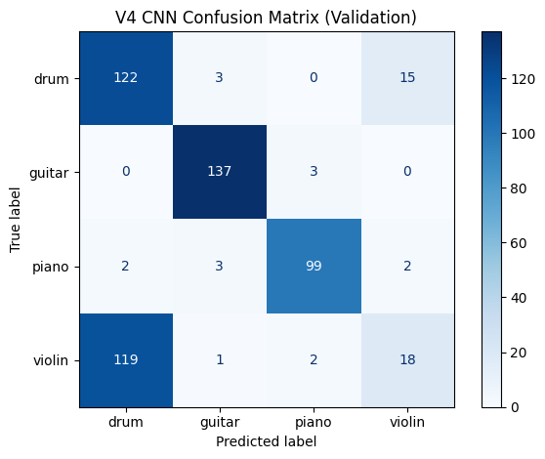
Figure 2: Validation confusion matrix for instrument CNN v4. The main remaining failure mode is violin being predicted as drum.

5 Combined Demo System
For the final demo, the two classifiers were presented as one music analysis system. The same audio clip is first passed through the genre model and then through the instrument model. This makes it possible to describe the clip in two complementary ways: a global musical style and a dominant instrument. A Beethoven clip was a strong live demo case because the genre model predicted classical and the instrument model predicted piano, which aligned well with what the audience could hear.
It is important not to overclaim what the system does. The current version is not a single multitask network, and the instrument model is single-label rather than multi-label. In other words, it predicts the dominant instrument rather than every instrument present in a mixture. Even so, the combined system is still a meaningful proof of concept because it demonstrates end-to-end audio classification for two distinct music-related tasks using a shared signal-processing philosophy.

6 Discussion
The strongest technical lesson from the genre pipeline was that reproducibility matters as much as peak accuracy. The earlier v4 result of 0.77 is still worth reporting because it showed the potential of the approach, but the later reruns are more trustworthy for a final report because their saved artifacts, code path, and reconnect-safe demo workflow were verified. That makes the 0.64 no-SpecAugment rerun the best practical reference point even though it is numerically worse than the earlier 0.77 result.
The strongest lesson from the instrument pipeline was different. There, the overall trend was much more stable, but class balance mattered. A model that improves headline accuracy can still make one class much worse, as happened with the drum-versus-violin tradeoff. This reinforced the importance of reading confusion matrices and per-class reports instead of relying on one summary score.
Taken together, the two tasks show why small audio datasets can still support meaningful machine-learning projects when the evaluation is honest. The models do learn real time-frequency structure, but they also reveal the limits of short crops, overlapping musical categories, and session-based notebook workflows. That combination of success and limitation makes the project more instructive than a single accuracy number alone.

7 Conclusion
This project produced a working music classification system with separate genre and dominant-instrument models built on log-mel spectrogram features and compact CNNs. The instrument model showed a reliable improvement over baseline, reaching 0.7148 validation accuracy. The genre model produced interpretable predictions and an earlier high result of 0.77, but the reproducible reruns settled in the 0.61 to 0.64 range and remained close to the 0.65 baseline. The most important outcome is therefore broader than one best score: the project demonstrated justified feature engineering, baseline comparison, CNN ablations, class-level error analysis, and a reconnect-safe demo workflow that made the final system usable in practice.

Acknowledgments

The project benefited from iterative notebook experiments, saved Colab artifacts, and the use of confusion matrices and classification reports to guide decisions rather than relying on accuracy alone.

References
Brian McFee, Colin Raffel, Dawen Liang, Daniel P. W. Ellis, Matt McVicar, Eric Battenberg, and Oriol Nieto. 2015. librosa: Audio and music signal analysis in Python. In Proceedings of the 14th Python in Science Conference.
Fabian Pedregosa, Gael Varoquaux, Alexandre Gramfort, Vincent Michel, Bertrand Thirion, Olivier Grisel, Mathieu Blondel, Peter Prettenhofer, Ron Weiss, Vincent Dubourg, et al. 2011. Scikit-learn: Machine learning in Python. Journal of Machine Learning Research, 12:2825–2830.
George Tzanetakis and Perry Cook. 2002. Musical genre classification of audio signals. IEEE Transactions on Speech and Audio Processing, 10(5):293–302.
Soumendra Prasad. 2021. Musical Instrument's Sound Dataset. Kaggle.
TensorFlow Developers. 2023. TensorFlow. https://www.tensorflow.org/.
https://github.com/GIX-Luyao/final-project-group-24

